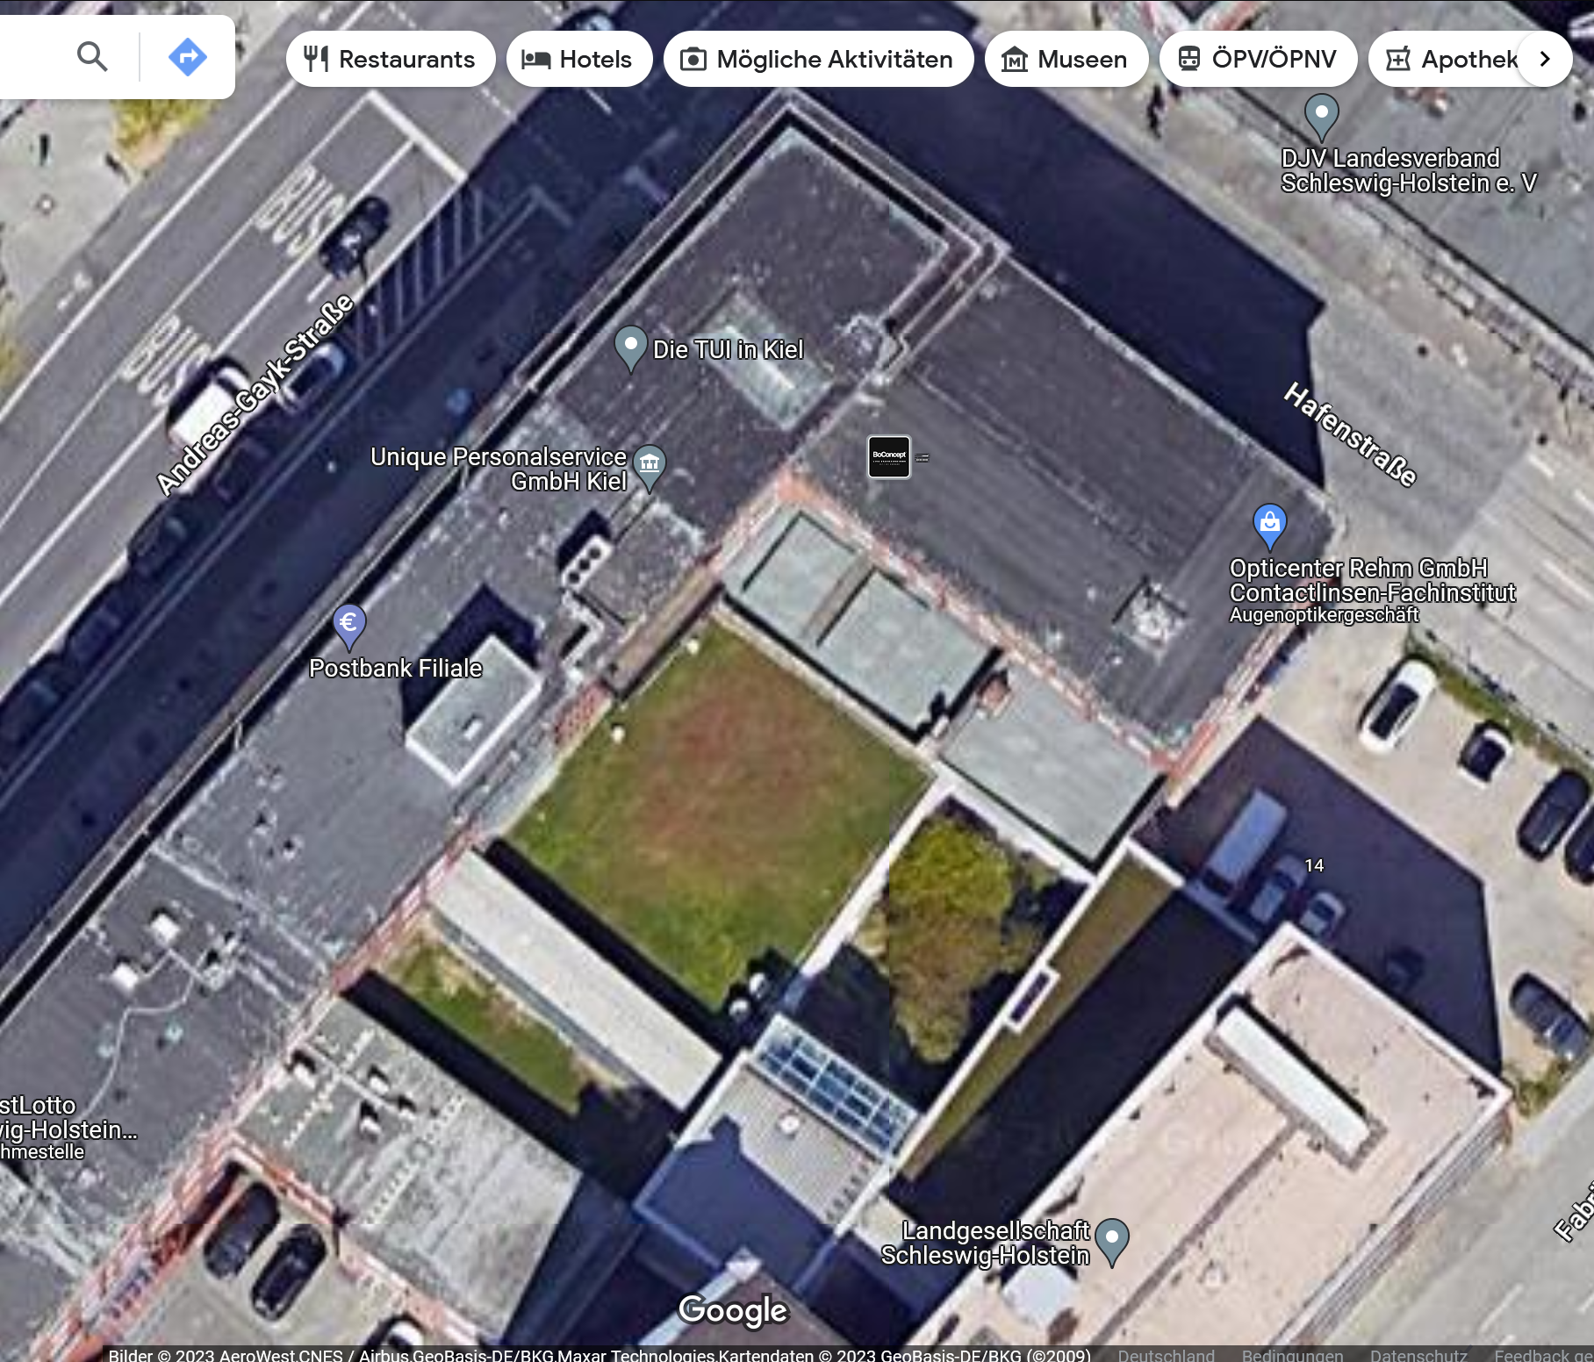
ABS 15-17
1
AGS 13
1
AGS 13
2
5
4
3
2

